ultramirinc.champs_mood.fragments

Class MyAdapterNotification

java.lang.Object android.support.v7.widget.RecyclerView.Adapter<MyViewHolderNotification>

ultramirinc.champs_mood.fragments.MyAdapterNotification



public class MyAdapterNotification

extends android.support.v7.widget.RecyclerView.Adapter<MyViewHolderNotification>

Created by William on 2017­04­06. This class creates a binding between the raw data and the visual interpretation of the notifications for a given User. This class binds it with a MyViewHolderNotifications object.

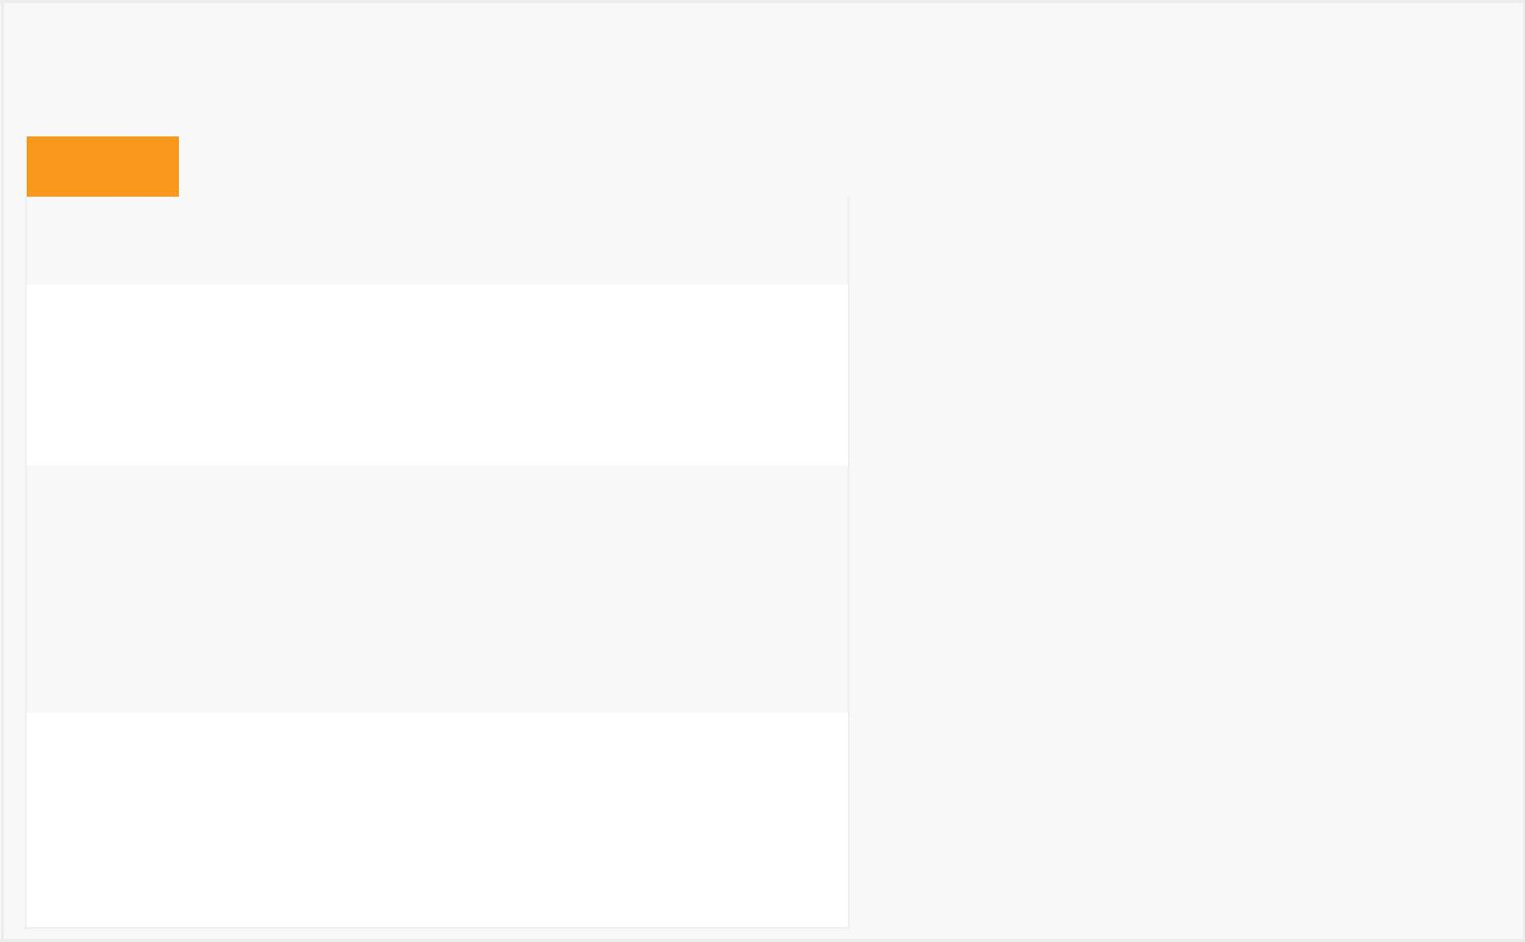

*Field Summary*

Fields

|  |  |
| --- | --- |
| Modifier and Type | Field and |
|  | Description |
| private android.content.Context | context |
|  | The |
|  | context to |
|  | the activity |
|  |  |
| private boolean | isPokable |
|  | Determines |
|  | if the |
|  | friend can |
|  | be poked |
|  | or not |
|  |  |

private java.util.List<Notification> list

Contains the list of the user's notification

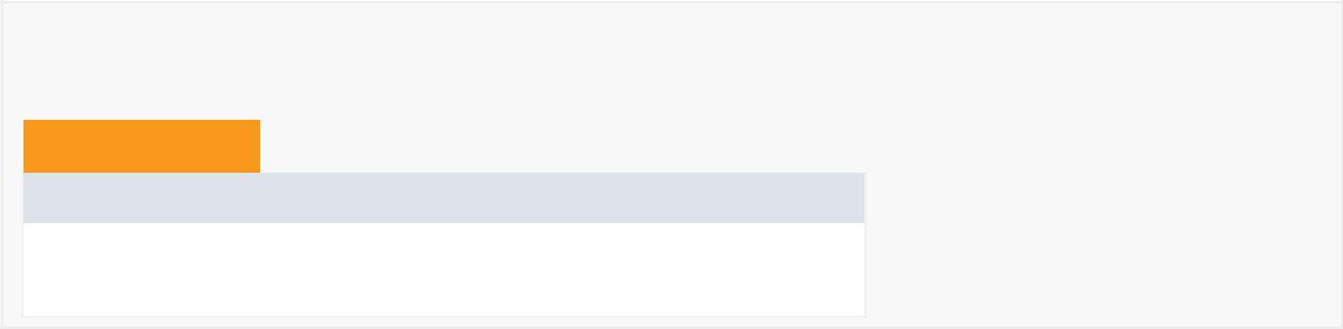

*Constructor Summary*

Constructors

Constructor and Description

MyAdapterNotification(java.util.List<Notification> list, android.content.Context context)

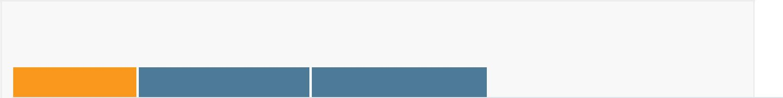

*Method Summary*

All Methods [Instance Methods](javascript:show(2);) [Concrete Methods](javascript:show(8);)



|  |  |
| --- | --- |
| Modifier and Type | Method and Description |
| int | getItemCount() |
|  | Returns the size of the list. |
|  |  |
| void | onBindViewHolder(MyViewHolderNotification myViewHolderNotification, |
|  | int position) |
|  | Binds the information from a given notification with the ViewHolder. |
| MyViewHolderNotification | onCreateViewHolder(android.view.ViewGroup viewGroup, int itemType) |
|  | Creates a Visual interpretation using a custom ViewHolder. |
|  |  |
| private void | poke(java.lang.String UserId) |
|  | Pokes a given user. |
|  |  |

Methods inherited from class android.support.v7.widget.RecyclerView.Adapter

bindViewHolder, createViewHolder, getItemId, getItemViewType, hasObservers, hasStableIds, notifyDataSetChanged, notifyItemChanged, notifyItemChanged, notifyItemInserted, notifyItemMoved, notifyItemRangeChanged, notifyItemRangeChanged, notifyItemRangeInserted, notifyItemRangeRemoved, notifyItemRemoved, onAttachedToRecyclerView, onBindViewHolder, onDetachedFromRecyclerView, onFailedToRecycleView, onViewAttachedToWindow, onViewDetachedFromWindow, onViewRecycled, registerAdapterDataObserver, setHasStableIds, unregisterAdapterDataObserver

Methods inherited from class java.lang.Object

clone, equals, finalize, getClass, hashCode, notify, notifyAll, toString, wait, wait, wait

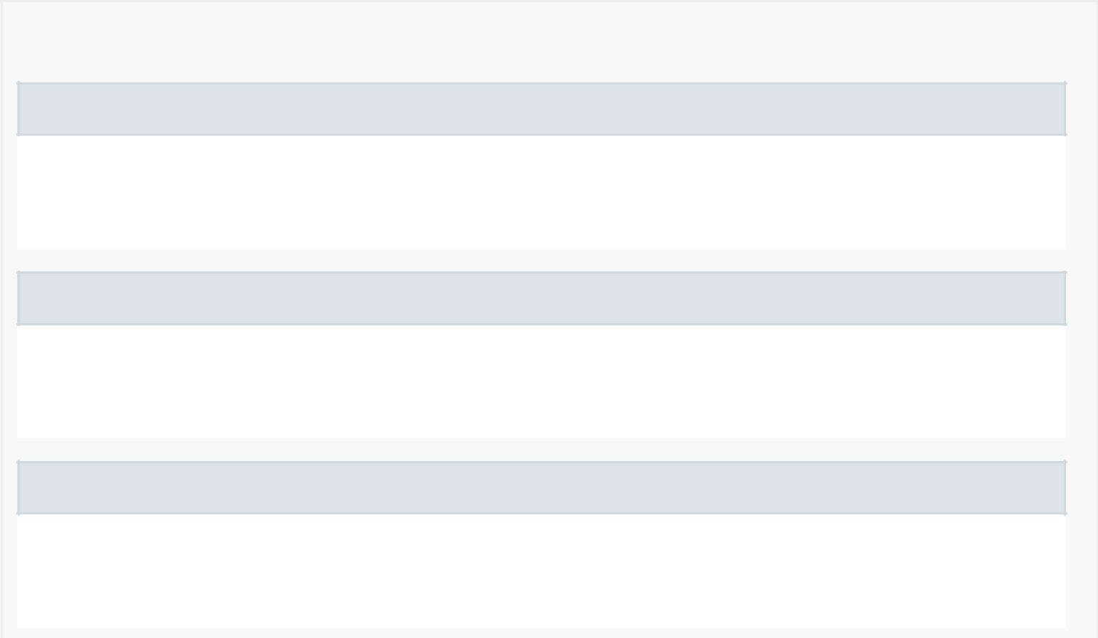

*Field Detail*

context

private android.content.Context context

The context to the activity

list

private java.util.List<Notification> list

Contains the list of the user's notification

isPokable

private boolean isPokable

Determines if the friend can be poked or not

*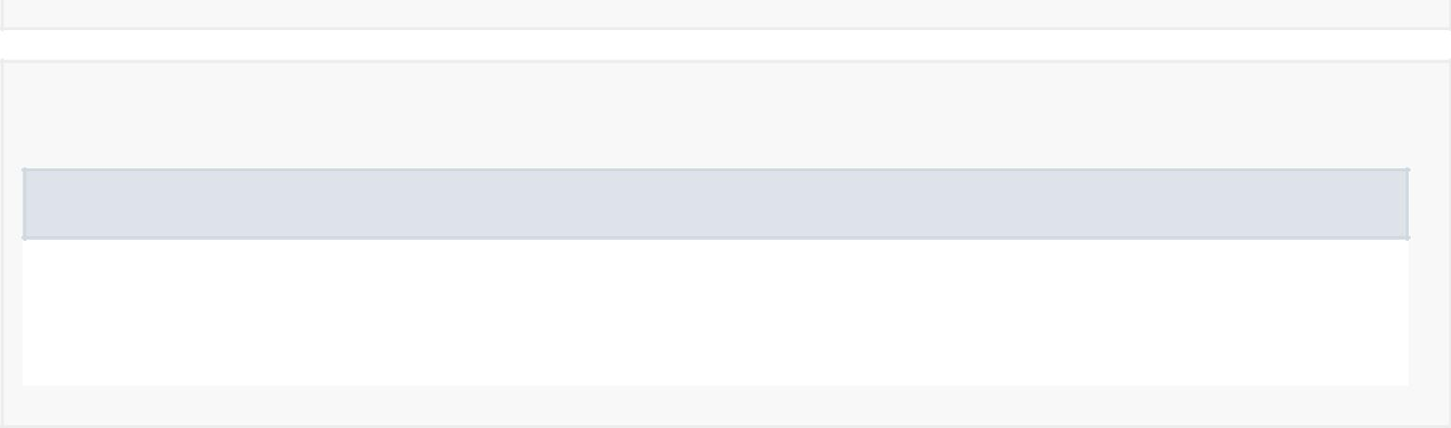Constructor Detail*

MyAdapterNotification

public MyAdapterNotification(java.util.List<Notification> list, android.content.Context context)

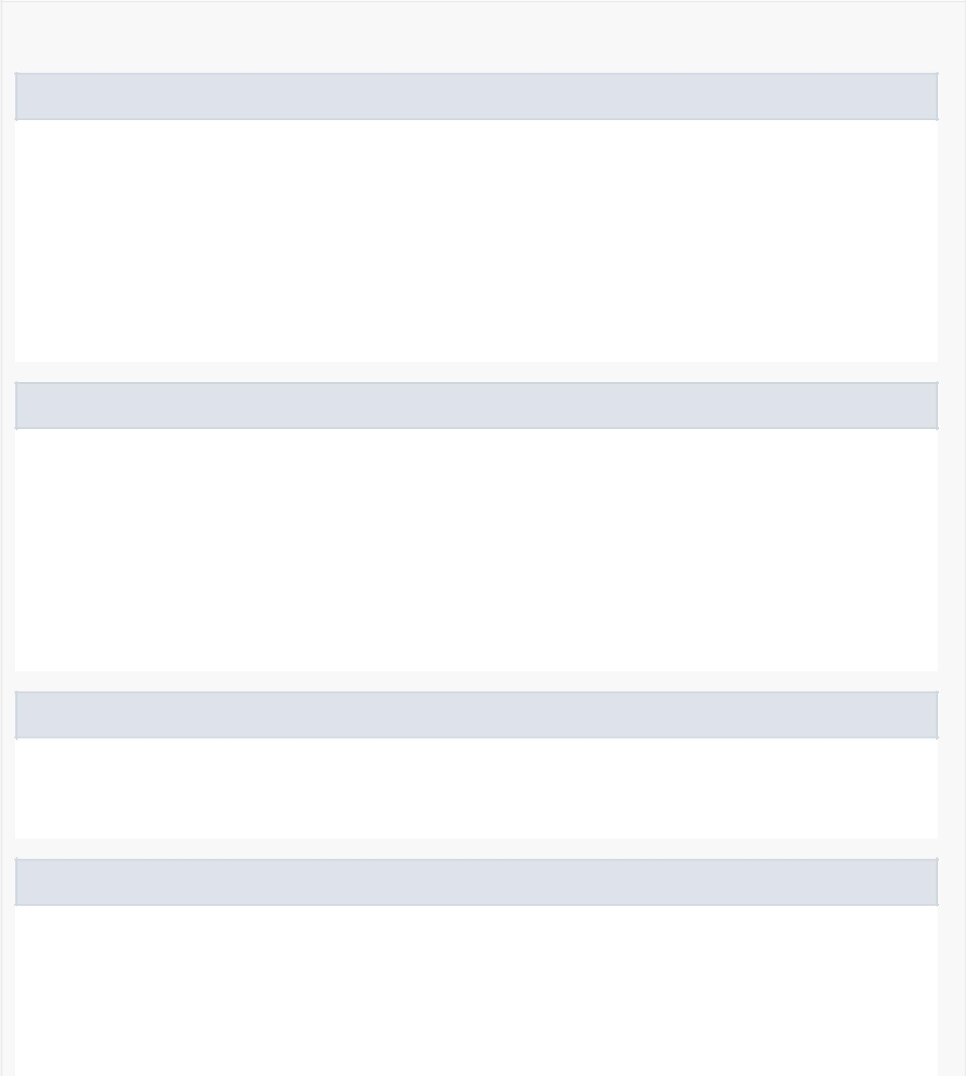

*Method Detail*

onCreateViewHolder

public MyViewHolderNotification onCreateViewHolder(android.view.ViewGroup viewGroup, int itemType)

Creates a Visual interpretation using a custom ViewHolder.

Specified by:

onCreateViewHolder in

class android.support.v7.widget.RecyclerView.Adapter<MyViewHolderNotification>

onBindViewHolder

public void onBindViewHolder(MyViewHolderNotification myViewHolderNotification, int position)

Binds the information from a given notification with the ViewHolder.

Specified by:

onBindViewHolder in

class android.support.v7.widget.RecyclerView.Adapter<MyViewHolderNotification>

poke

private void poke(java.lang.String UserId)

Pokes a given user.

getItemCount

public int getItemCount()

Returns the size of the list.

Specified by:

getItemCount in

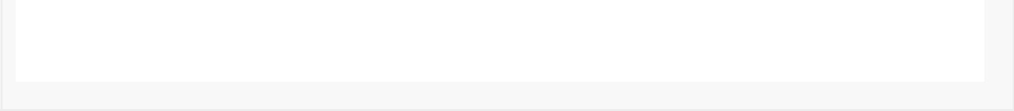

class android.support.v7.widget.RecyclerView.Adapter<MyViewHolderNotification>